Customer Segmentation Analysis Project Report
ana555 pRACTICUM IN aPPLIED ANALYTICS
William Edgar KOROMPIS 1124269
2025
Table of Contents
Table of Contents 1
List of Figures 2
List of Tables 3
Abstract 4
Introduction 4
Literature Review 6
Methodology 8
Results and Discussion 13
Conclusion 31

List of Figures

Figure 1 Project Workflow Diagram (SQL Data Extraction → Python Modeling → Tableau Visualization) 5
Figure 2 Elbow Curve for Optimal K 10
Figure 3 PCA Cluster Scatterplot 11
Figure 4 Distribution of Age 17
Figure 5 Distribution of Bike-related Purchases Over The Past Three Years 17
Figure 6 Distribution of Property Valuation 18
Figure 7 Distribution of Total Spent 19
Figure 8 Distribution of Transaction Count 19
Figure 9 Distribution of days_since_last_purchase 20
Figure 10 Distribution of Customer Tenure Days 20
Figure 11 Boxplot of Age 21
Figure 12 Boxplot of past_3_years_bike_related_purchases 22
Figure 13 Boxplot of Property Valuation 22
Figure 14 Boxplot of Total Spent 23
Figure 15 Boxplot of Transaction Count 23
Figure 16 Boxplot of days_since_last_purchase 24
Figure 17 Boxplot of Customer Tenure Days 24
Figure 18 Gender Distribution Bar Plot 26
Figure 19 Job Industry Distribution Bar Plot 27
Figure 20 Customer Wealth Segment Bar Plot 28
Figure 21 Car Ownership Distribution Bar Plot 29
Figure 22 Customer State Distribution Bar Plot 30

List of Tables

Table 1 Data Attributes Extracted via SQL 7
Table 2 Silhouette Score Comparison 9
Table 3 Age Cluster Profiling 14
Table 4 past_3_years_bike_related_purchases Age Cluster Profiling 14
Table 5 Property Valuation Cluster Profiling 14
Table 6 Total Spent Cluster Profiling 15
Table 7 Transaction Count Cluster Profiling 15
Table 8 days_since_last_purchase Cluster Profiling 15
Table 9 Customer Tenure Days Cluster Profiling 15
Table 10 Age Profiling 24
Table 11 Job Industry Category Profiling (a) 25
Table 12 Job Industry Category Profiling (b) 25
Table 13 Wealth Segment Profiling 26
Table 14 Car Ownership Profiling 27
Table 15 State Distribution Profiling 28

Abstract
Customer segmentation enables businesses to target distinct customer groups more effectively. This project aimed to segment customers of an Australian bike store to support data-driven marketing and retention strategies. Using transactional, demographic, and geographic data, K-Means clustering was applied to group customers based on purchasing behavior, socio-economic indicators, and engagement patterns. The analysis identified high-value frequent buyers, dormant customers, and mid-tier segments with growth potential. These findings provide actionable insights for tailoring promotions, optimizing resource allocation, and enhancing customer loyalty programs, offering a practical framework for improving marketing efficiency and business performance.

Introduction
In today’s competitive e-commerce environment, businesses strive to personalize their marketing efforts to maximize engagement and drive profitability. Customer segmentation serves as a vital approach, enabling companies to categorize their customer base into distinct groups based on behaviors, preferences, and demographics. Despite its significance, many organizations fail to implement effective segmentation models, resulting in inefficient marketing strategies and wasted resources.
This project addresses this challenge by developing a comprehensive customer segmentation model for an Australian bike store. Utilizing transactional data, demographic attributes, and geographic information, the project aims to uncover patterns that distinguish high-value customers from dormant or low-engagement segments. By integrating SQL for data extraction, Python for preprocessing and clustering, and Tableau for visual analytics, the project ensures a seamless workflow from raw data to actionable business insights.
The segmentation outcomes are intended to assist the bike store in optimizing its marketing campaigns, focusing on high-value segments, and devising reactivation strategies for at-risk customers. Additionally, the visual analytics component offers an intuitive understanding of segment characteristics, aiding in strategic decision-making. This report details the foundation of literature, methodological framework, and analytical findings, providing a roadmap for data-driven customer engagement strategies.
Not only improves marketing efficiency, but customer segmentation also enhances customer experience by delivering personalized services. In the context of a bike store, understanding customer preferences—such as product categories, frequency of purchases, and geographic trends—can inform decisions about inventory management, promotional offers, and customer support initiatives. By segmenting customers based on data-driven insights, businesses can move beyond generic marketing strategies and instead deploy targeted campaigns that resonate with specific audience groups. This approach fosters stronger customer relationships, increases loyalty, and ultimately drives sustainable business growth
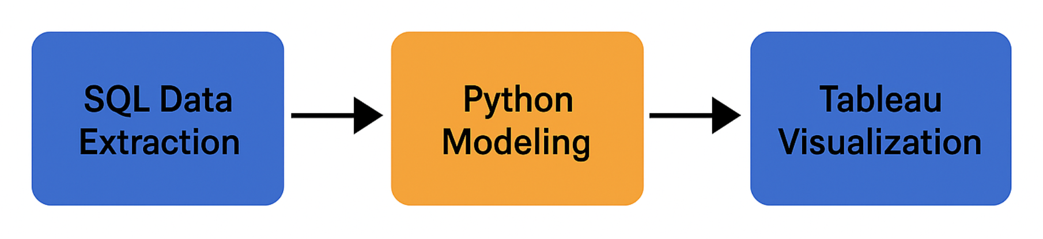
Figure 1 Project Workflow Diagram (SQL Data Extraction → Python Modeling → Tableau Visualization)

Literature Review
Customer segmentation is a cornerstone of modern marketing analytics, providing businesses with the insight needed to target distinct customer groups effectively. Among the various segmentation techniques, K-Means clustering is widely regarded for its simplicity, scalability, and ability to reveal natural groupings within datasets. This unsupervised learning algorithm partitions data into distinct clusters based on feature similarity, making it a popular choice for retail and e-commerce applications.
Aslantaş et al. (2023) explored the integration of K-Means with the RFM (Recency, Frequency, Monetary) model, successfully segmenting retail customers into high-value, loyal, and at-risk categories. Ravi and Reddy (2022) underscored the importance of thorough data preprocessing and feature scaling, demonstrating how these steps enhance clustering accuracy in retail purchase datasets. John et al. (2024) provided a comparative analysis of clustering algorithms, affirming K-Means' effectiveness, particularly when applied to RFM-derived features within large customer datasets. They stated, "K-Means consistently outperformed DBSCAN and Hierarchical Clustering in terms of segmentation clarity and computational efficiency when handling high-volume transactional data." Sarkar et al. (2024) introduced AI-driven enhancements to traditional K-Means segmentation, emphasizing the role of visual analytics in improving the interpretability and business applicability of clustering outcomes. According to their findings, "The integration of AI-based post-segmentation analysis allowed for deeper insights into segment behaviors, which would have been overlooked using conventional clustering methods alone." Zhao (2024) offered a detailed methodology for implementing K-Means in business contexts, guiding practitioners through data normalization, cluster evaluation, and translating analytical insights into actionable strategies. Zhao emphasized, "The success of K-Means in business applications hinges on a rigorous preprocessing pipeline, without which cluster results can be misleading and unaligned with business objectives."
Additionally, the evolution of customer segmentation techniques has been influenced by the increasing availability of granular data, which enables businesses to develop more sophisticated models. Machine learning advancements have allowed for hybrid approaches that combine clustering with predictive analytics to forecast customer lifetime value and churn risk. Real-time segmentation is also gaining traction, allowing businesses to dynamically adjust their strategies based on live customer data. Visual analytics tools, such as Tableau and Power BI, play a critical role in making these complex models accessible and actionable for business users by translating numerical clusters into intuitive visual narratives.
Collectively, these studies provide a robust foundation for adopting K-Means clustering in customer segmentation projects. They highlight the critical importance of preprocessing, feature selection, and visual analytics in ensuring segmentation results are both statistically sound and business relevant. The methodologies and findings from these studies have been directly applied in structuring this project’s analytical approach.

Methodology
Data Extraction with SQL
The initial phase involved extracting data from multiple relational tables, including transactions, which consist of transactions in the year of 2017, customer demographics, addresses, and a new customer list. SQL queries were crafted to join these datasets using customer_id and transaction_id as primary keys. INNER JOIN operations ensured a unified view of each customer by merging demographic and address details with transaction history. Filtering techniques were applied to eliminate NULL values, maintaining data quality. Aggregate functions such as SUM() and COUNT() generated key variables like total spend and transaction count per customer, forming a comprehensive dataset for analysis.
Table 1 Data Attributes Extracted via SQL
Attribute Name | Description | Source Table | Aggregation Type
customer_id | Unique identifier for each customer | CleanedCustomerDemographic | None (Primary Key)
gender | Customer’s gender (normalized to Male/Female) | CleanedCustomerDemographic | None
age | Age of the customer | CleanedCustomerDemographic | None
job_industry_category | Customer’s job industry classification | CleanedCustomerDemographic | None
wealth_segment | Wealth classification of the customer | CleanedCustomerDemographic | None
owns_car | Indicates if the customer owns a car | CleanedCustomerDemographic | None
state | State where the customer resides | CleanedCustomerAddress | None
country | Country of residence | CleanedCustomerAddress | None
property_valuation | Valuation of the customer's property | CleanedCustomerAddress | None
total_spent | Total monetary value spent by the customer | CleanedTransactions | SUM(list_price)
transaction_count | Total number of transactions per customer | CleanedTransactions | COUNT(transaction_id)
most_recent_purchase | Latest transaction date for the customer | CleanedTransactions | MAX(transaction_date)
first_purchase | Earliest transaction date for the customer | CleanedTransactions | MIN(transaction_date)
past_3_years_bike_related_purchases | Number of bike-related purchases in the past 3 years | CleanedCustomerDemographic | None

Data Preprocessing in Python
The dataset was imported into Python for preprocessing. Missing values were addressed by removing rows with incomplete critical data. Categorical variables such as gender, job industry category, and state were encoded using one-hot encoding. Continuous numerical features were standardized using StandardScaler to ensure balanced weighting in distance-based clustering models. Feature engineering created additional attributes like Average Spend per Transaction, Days Since Last Purchase (Recency), and Customer Tenure.
K-Means Clustering Modeling
The optimal number of clusters was determined using the Elbow Method and Silhouette Score.
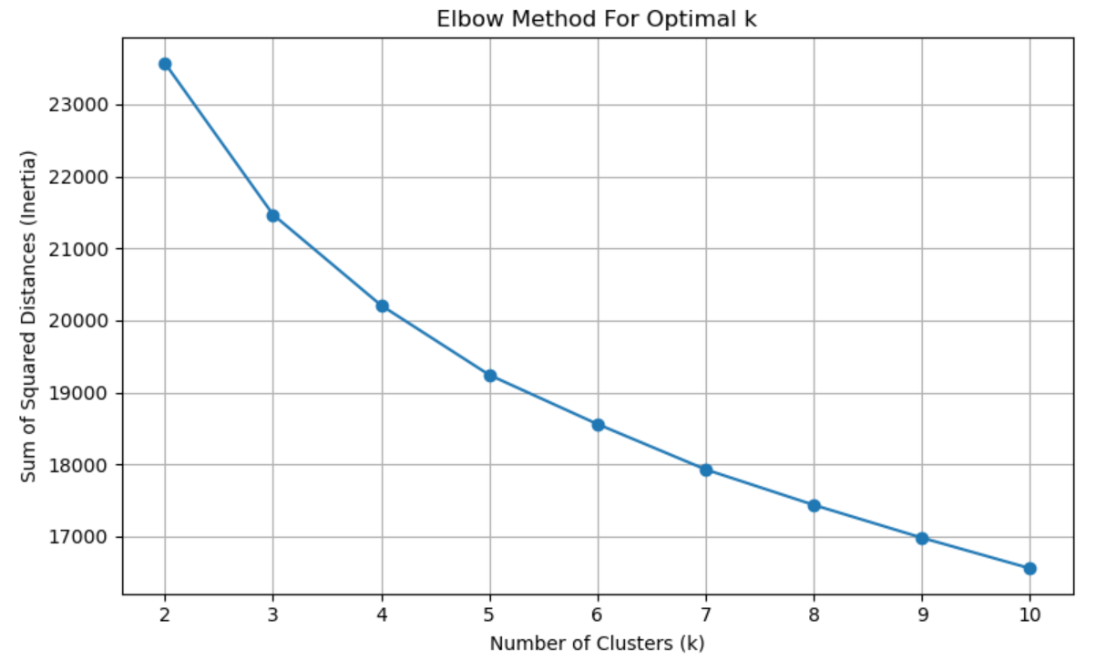
Figure 2 Elbow Curve for Optimal K

Table 2 Silhouette Score Comparison
Silhouette Score for Each k Value
k value | Silhouette Score
2 | 0.1533
3 | 0.1151
4 | 0.1117
5 | 0.1009
6 | 0.0939
7 | 0.0914
8 | 0.0862
9 | 0.0872
10 | 0.0897
Once k was finalized, the K-Means algorithm was applied to segment customers into distinct clusters. PCA (Principal Component Analysis) was used to reduce feature dimensionality and visualize clusters in a 2D space.
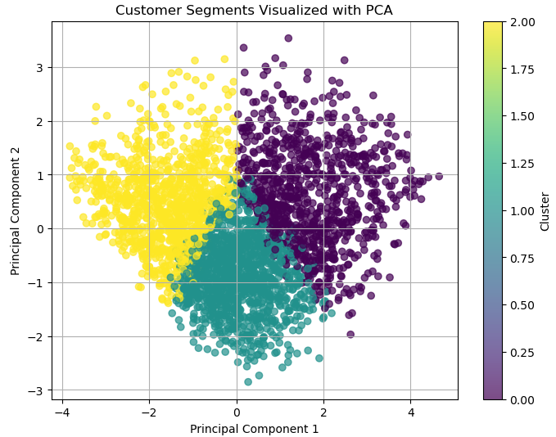
Figure 3 PCA Cluster Scatterplot
Visualization in Tableau
- The clustered dataset was imported into Tableau to construct an interactive dashboard that provides a comprehensive view of customer segments and their behaviors. The dashboard includes:
- Cluster Overview – A bar chart showing the proportion of customers in each segment, enabling quick assessment of segment sizes.
- Gender Distribution – Stacked bar charts comparing the distribution of male and female customers within each cluster, highlighting demographic balance.
- Total Spend by Cluster – Boxplots illustrating the spread, median, and variability of total customer spending for each segment, helping identify high-value and low-spending groups.
- Purchase Timeline – A line chart tracking cumulative spending trends over time by cluster, revealing seasonal activity patterns and periods of higher engagement.
- Geographic Distribution Map – A filled map showing customer concentrations across Australian states (NSW, VIC, QLD), supporting geographic targeting strategies.
- These interactive visuals allow users to drill down by segment, time period, or geography, making it possible to connect cluster characteristics to actionable business strategies.

Results and Discussion
Chosen K Value
The optimal number of clusters was determined using the Elbow Method and Silhouette Score, resulting in k = 3 as the final selection. This provided a balance between segmentation clarity and actionable differentiation across customer groups.
Cluster Names & Descriptions
Cluster 0 – Balanced Mid-Value Buyers
- Description: Customers in this segment exhibit moderate total spending, reasonable purchase frequency, and an average recency of ~35 days. They have the longest average tenure (286 days), indicating established relationships with the store.
- Demographics: Balanced gender distribution, majority residing in NSW (50%), followed by QLD (25%) and VIC (24%). Wealth segment is primarily Mass Customer (52%), with smaller proportions of Affluent and High Net Worth. Strong industry presence in Manufacturing (19.8%) and Financial Services (20.6%).
- Behavior: Regular purchases and steady engagement over time.
- Strategy: Maintain loyalty through seasonal promotions and targeted campaigns focused on mid-range products and value bundles.
Cluster 1 – High-Value Frequent Loyalists
- Description: This is the most valuable segment, with the highest total spending, highest transaction count, and shortest recency (~31 days). Tenure is also long (278 days), reflecting strong loyalty and consistent engagement.
- Demographics: Balanced gender representation, with NSW as the dominant state (62%). Slightly higher proportion of High-Net-Worth customers (26.4%). Key industries include Manufacturing (20.4%), Financial Services (19.1%), and Property (8.6%).
- Behavior: High purchase frequency and sustained engagement.
- Strategy: Retain through VIP programs, early access to products, and premium service offerings.
Cluster 2 – At-Risk or Infrequent Buyers
- Description: Characterized by the longest recency (~100 days) and shortest tenure (~178 days), indicating many are new or disengaged customers. Spending and transaction counts are the lowest among the clusters.
- Demographics: Slight female majority (53.5%), most residing in NSW (49%) and VIC (27%). Wealth distribution is similar to other clusters, with Mass Customer just under half. Slightly higher Manufacturing representation (22%).
- Behavior: Low purchase frequency and sporadic engagement.
- Strategy: Implement re-engagement initiatives, offer welcome discounts to newer customers, and promote targeted product recommendations to encourage repeat purchases.
Numerical Profiling of Segments
The numerical profiling highlighted further distinctions among the clusters. Age was consistent across groups, with mean values near 48 years and similar spread (standard deviation ~12.5 years). For past three years’ bike-related purchases, Cluster 1 recorded the highest mean (50.32) compared to Cluster 0 (48.42) and Cluster 2 (48.90), though all groups showed wide variability, with minimum values at zero and maximum near 99 purchases. Property valuation (not shown in the images but present in the dataset) displayed moderate variation, indicating a mix of customer asset levels across clusters. Total spending and transaction count trends pointed to Cluster 1 as the highest-spending and most transactionally active group, while Clusters 0 and 2 showed lower but steady engagement. Recency of purchase (days since last purchase) was markedly different: Cluster 0 had the longest average gap between purchases (104.50 days), suggesting lower recent engagement, whereas Clusters 1 and 2 had shorter intervals (30.42 and 36.29 days, respectively). Customer tenure was longest in Cluster 2 (286.07 days) and Cluster 1 (279.00 days), indicating more established relationships with the store, while Cluster 0 had the shortest tenure (173.49 days). These numerical differences reinforce the behavioral segmentation indicated by the categorical profiling, particularly highlighting Cluster 1’s high activity and Cluster 0’s relatively lower engagement despite a sizable historical relationship.
Table 3 Age Cluster Profiling
cluster | mean | median | min | max | std
0 | 47.97413 | 48 | 23 | 72 | 12.47314
1 | 47.60531 | 48 | 23 | 72 | 12.69986
2 | 48.02621 | 48 | 24 | 72 | 12.42346

Table 4 past_3_years_bike_related_purchases Age Cluster Profiling
cluster | mean | median | min | max | std
0 | 48.41732 | 48 | 0 | 99 | 28.99356
1 | 50.31675 | 50.5 | 0 | 99 | 28.7861
2 | 48.89612 | 48 | 0 | 99 | 28.17925

Table 5 Property Valuation Cluster Profiling
cluster | mean | median | min | max | std
0 | 7.490439 | 8 | 1 | 12 | 2.837206
1 | 7.533167 | 8 | 1 | 12 | 2.788859
2 | 7.504854 | 8 | 1 | 12 | 2.879753

Table 6 Total Spent Cluster Profiling
cluster | mean | median | min | max | std
0 | 4717.103 | 4653.39 | 142.98 | 10936.2 | 1939.516
1 | 5075.57 | 5139.07 | 458.74 | 8633.69 | 1446.587
2 | 9255.45 | 9000.8 | 5364.14 | 14065.03 | 1734.933

Table 7 Transaction Count Cluster Profiling
cluster | mean | median | min | max | std
0 | 4.313836 | 4 | 2 | 8 | 1.443937
1 | 4.921227 | 5 | 2 | 8 | 1.210438
2 | 7.994175 | 8 | 6 | 11 | 1.297364

Table 8 days_since_last_purchase Cluster Profiling
cluster | mean | median | min | max | std
0 | 104.5028 | 103 | 0 | 190 | 42.00888
1 | 30.41708 | 25 | 0 | 96 | 22.56688
2 | 36.2932 | 30 | 0 | 137 | 28.4639

Table 9 Customer Tenure Days Cluster Profiling
cluster | mean | median | min | max | std
0 | 173.4938 | 179 | 56 | 267 | 49.88679
1 | 279.005 | 283 | 139 | 360 | 43.82504
2 | 286.0748 | 292 | 133 | 362 | 43.031

Histograms and Distributions
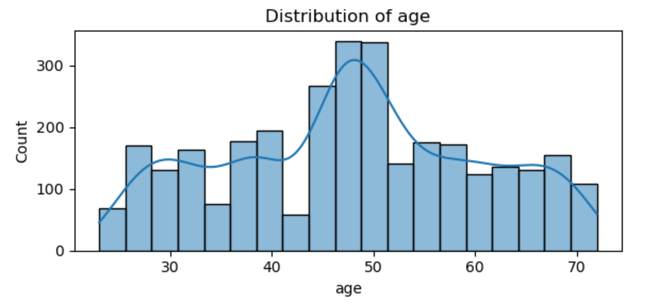
Figure 4 Distribution of Age

The distribution plots provide a clear picture of how the numerical features are spread across the customer base. The age distribution is slightly right-skewed, with the majority of customers falling between 35 and 60 years old. This suggests that the store primarily serves middle-aged adults, aligning with typical demographics for recreational or commuter cyclists.
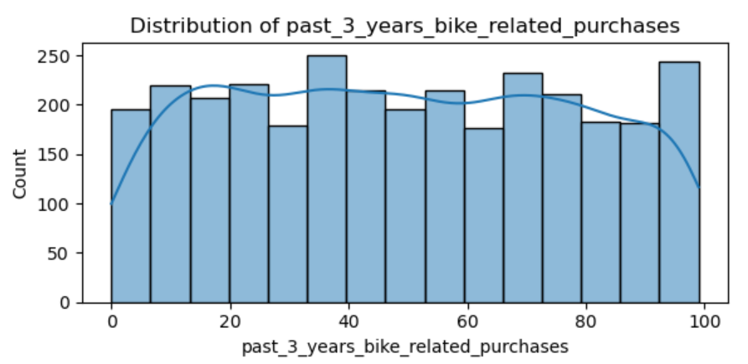
Figure 5 Distribution of Bike-related Purchases Over The Past Three Years

The feature representing bike-related purchases over the past three years is relatively uniform in distribution, with customers spread across all levels of engagement — from those with zero purchases to those with nearly 100. This broad variation indicates a healthy mix of new, occasional, and frequent buyers in the customer base, which supports the motivation for clustering.
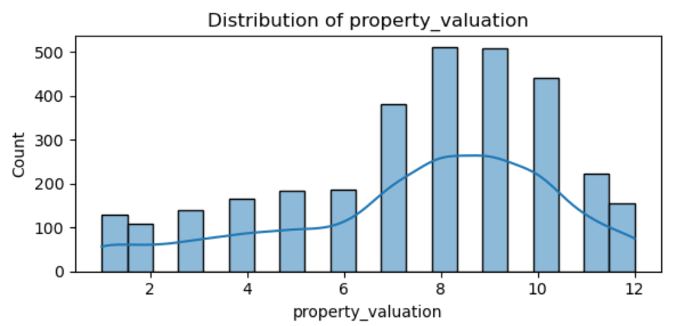
Figure 6 Distribution of Property Valuation

For property valuation, the distribution is left-skewed, with a concentration of customers living in moderately valued properties ranging from 7 to 10 on the valuation scale. This may reflect a largely middle-class customer base, though there are customers from both lower and higher-value property segments.
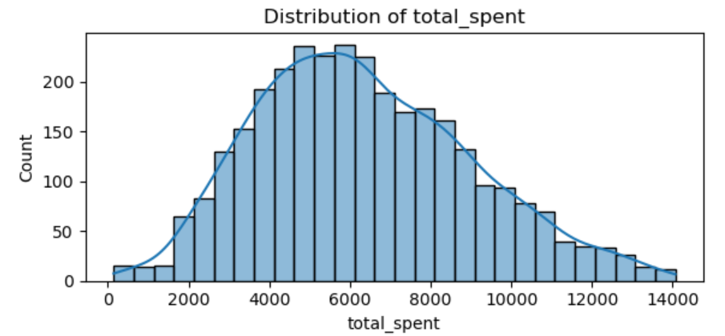
Figure 7 Distribution of Total Spent

The total_spent variable displays a slightly right-skewed, bell-shaped distribution. Most customers fall in the range of $4,000 to $8,000 in lifetime spending, but there are some who exceed $10,000, contributing to a long right tail. This distribution confirms that while the average customer spends a moderate amount, there exists a notable segment of high-value customers.
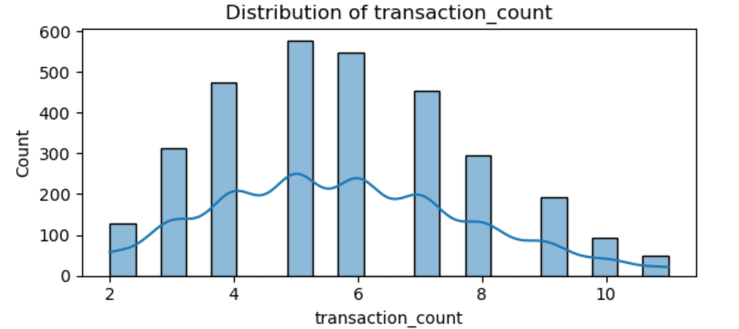
Figure 8 Distribution of Transaction Count
In examining transaction_count, the distribution resembles a normal curve centered around six transactions. This implies that the typical customer makes multiple purchases, although the spread suggests varying levels of loyalty or product interest.
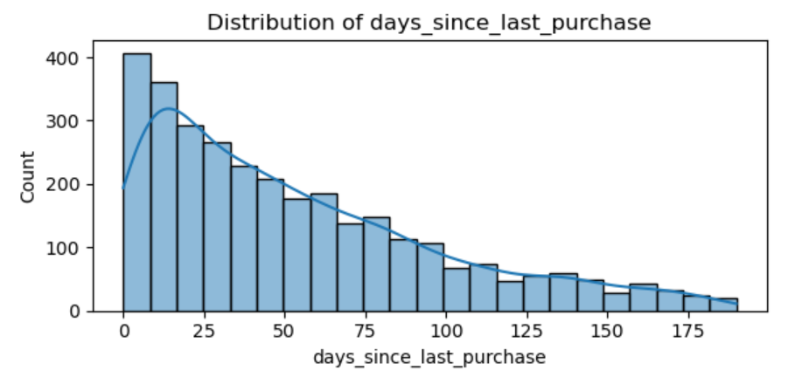
Figure 9 Distribution of days_since_last_purchase
The days_since_last_purchase feature is heavily right-skewed. A large number of customers have made purchases recently, but there is a long tail of customers who have not engaged in a long time. This trend is useful in identifying lapsed or at-risk customers.
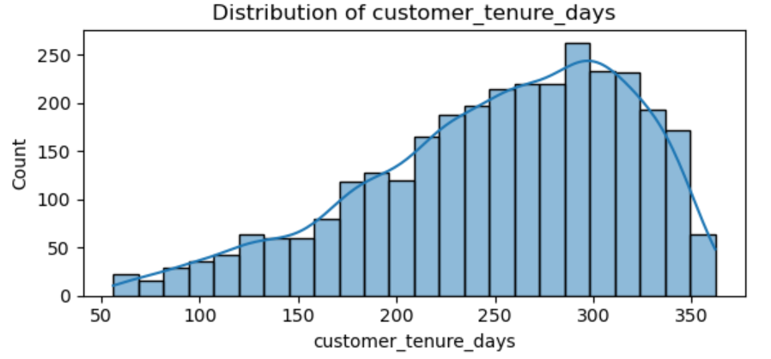
Figure 10 Distribution of Customer Tenure Days
Lastly, the distribution of customer_tenure_days is approximately normal, centered around 250–300 days, indicating that most customers have maintained a relationship with the store for close to a year. However, a range of tenure durations exists, reflecting both newly acquired and long-standing customers.
Boxplots and Outlier Inspection
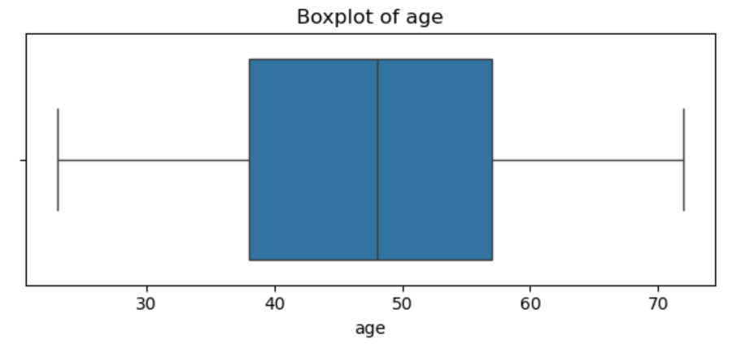
Figure 11 Boxplot of Age
Boxplots were used to visually assess the spread and detect outliers for each numeric feature. In the case of age, the distribution appears symmetrical, with most values tightly clustered around the median of 48. There are no extreme outliers, suggesting a consistent customer age group.
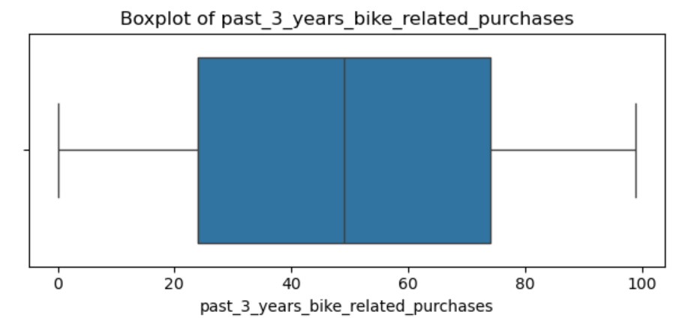
Figure 12 Boxplot of past_3_years_bike_related_purchases
The past_3_years_bike_related_purchases boxplot shows a similar balance, although a wider interquartile range reflects the broader behavioral diversity in buying patterns.
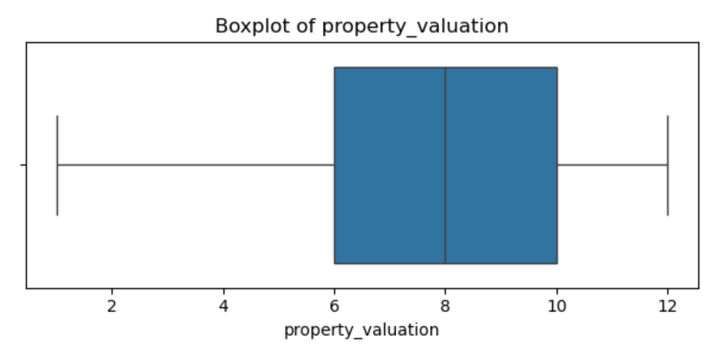
Figure 13 Boxplot of Property Valuation
Property valuation is also quite stable across customers, with most values lying within the expected range of 6 to 10.
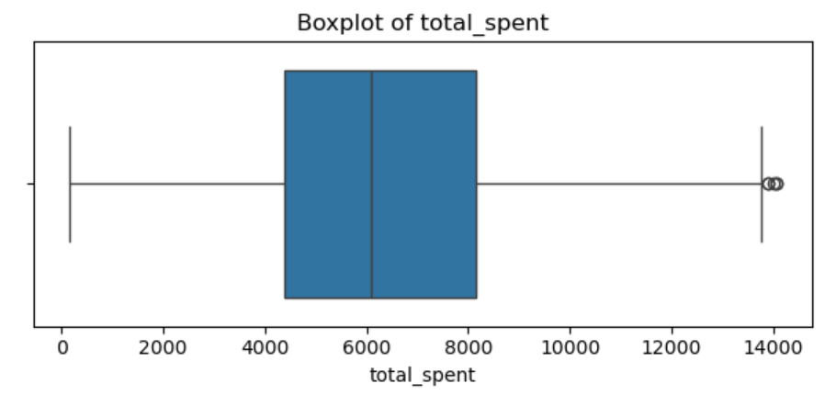
Figure 14 Boxplot of Total Spent
More variation becomes evident when examining total_spent. While the central mass of customers falls between $4,000 and $8,000, the boxplot reveals several high-spending outliers exceeding $12,000. These customers likely represent highly engaged or premium buyers.
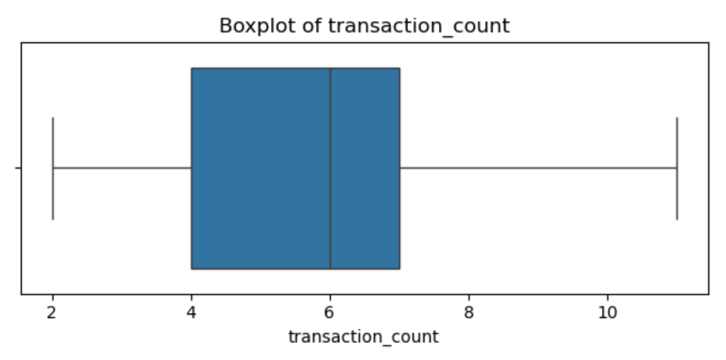
Figure 15 Boxplot of Transaction Count
Similarly, transaction_count shows a concentration between 4 and 7 transactions, but with upper-end outliers that again suggest high-engagement segments.
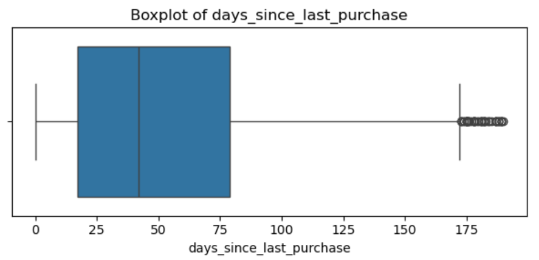
Figure 16 Boxplot of days_since_last_purchase
The days_since_last_purchase boxplot is notably skewed with a dense cluster near the lower bound, reflecting many recent buyers, and a scattering of outliers past 150 days, highlighting disengaged or lapsed customers.
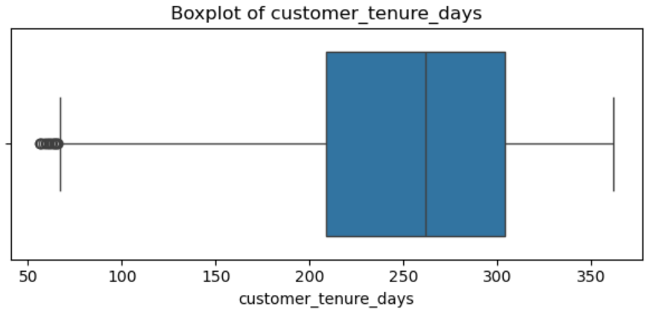
Figure 17 Boxplot of Customer Tenure Days
In contrast, the customer_tenure_days boxplot shows a strong central tendency with a wide range from 56 to 362 days. Outliers on the lower end reflect newer customers, while longer-tenure customers offer insights into loyalty and retention.
Overall, while some outliers were detected in variables like total_spent, days_since_last_purchase, and customer_tenure_days, they were retained in the analysis, as they likely reflect genuine customer behaviors rather than data errors. The boxplot analysis not only confirms the histogram trends but also highlights areas of natural segmentation, making these features especially valuable for clustering.
Cluster Profiling with Categorical Features
The categorical profiling revealed distinct demographic and behavioral patterns across clusters. In terms of gender, the distribution was relatively balanced, with each cluster showing near-equal representation of male and female customers, ranging from approximately 46% to 54% for each gender.
Table 10 Age Profiling
cluster | Female | Male
0 | 53.8 | 46.2
1 | 51.3 | 48.7
2 | 50.3 | 49.7

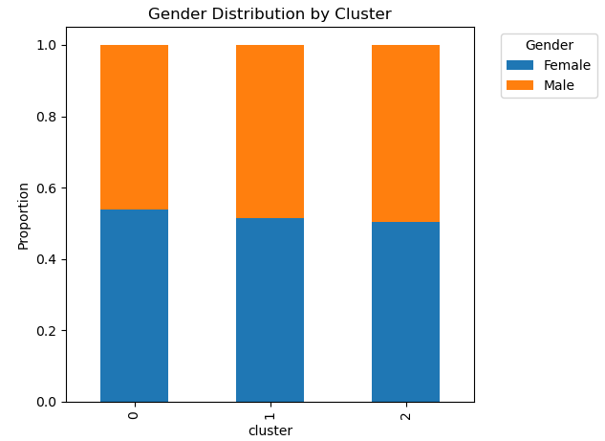
Figure 18 Gender Distribution Bar Plot
The job industry category varied across clusters, with Manufacturing and Financial Services emerging as dominant sectors in all groups. Cluster 0 had the highest share in Manufacturing (21.71%), while Cluster 2 had slightly higher representation in Retail (9.71%) compared to others.
Table 11 Job Industry Category Profiling (a)
cluster | Argiculture | Entertainment | Financial Services | Health | IT
0 | 2.2 | 3.8 | 19.5 | 14.2 | 4.3
1 | 3.2 | 3.1 | 19.5 | 16 | 3.6
2 | 2.8 | 3.7 | 21.1 | 16.2 | 3.2

Table 12 Job Industry Category Profiling (b)
cluster | Manufacturing | Property | Retail | Telecommunications | Unknown
0 | 21.7 | 6.4 | 8.7 | 2.1 | 17.1
1 | 21 | 7.6 | 7.9 | 1.5 | 16.7
2 | 19.4 | 6.3 | 9.7 | 2 | 15.5

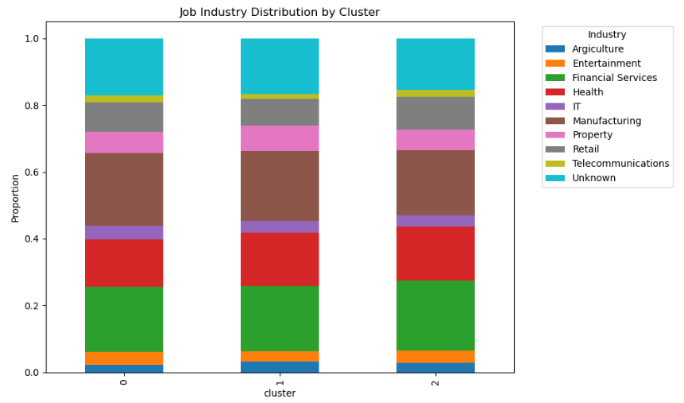
Figure 19 Job Industry Distribution Bar Plot
The wealth segment distribution indicated that Mass Customers formed the largest group in all clusters, exceeding 48% in each case, while High Net Worth and Affluent Customers were more evenly split in the remaining proportions.
Table 13 Wealth Segment Profiling
cluster | Affluent Customer | High Net Worth | Mass Customer
0 | 25.4 | 25.9 | 48.7
1 | 24.5 | 26.9 | 48.6
2 | 23.7 | 24.5 | 51.8

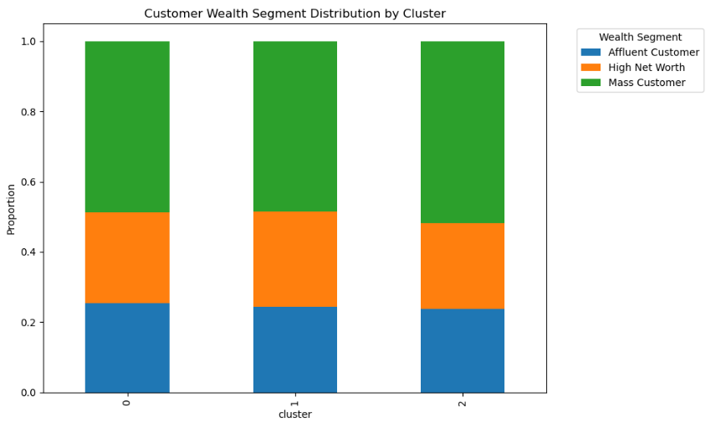
Figure 20 Customer Wealth Segment Bar Plot
Car ownership showed minimal differences across clusters, with “Yes” and “No” responses both hovering around 50%.
Table 14 Car Ownership Profiling
cluster | No | Yes
0 | 50.2 | 49.8
1 | 48.7 | 51.3
2 | 49.5 | 50.5

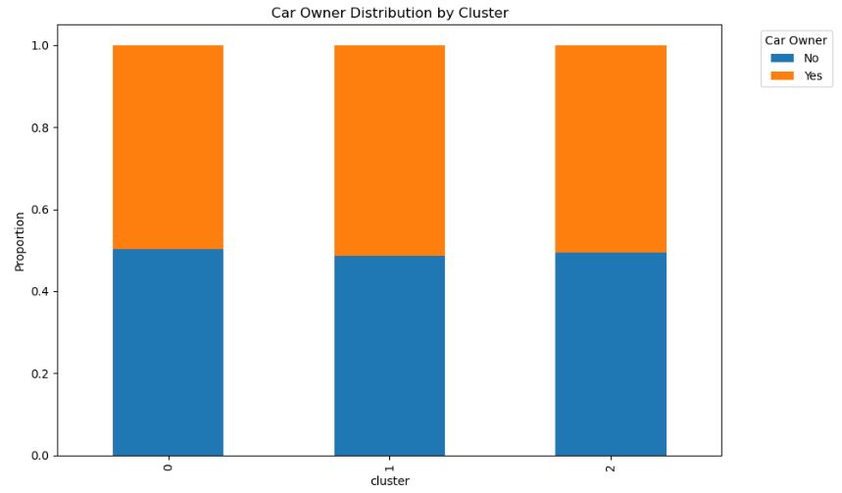
Figure 21 Car Ownership Distribution Bar Plot
Finally, state distribution indicated a consistent dominance of customers from New South Wales (50–55%), followed by Victoria (23–28%) and Queensland (21–22%). These patterns suggest that while clusters share similarities in demographic composition, there are subtle differences in industry representation and regional spread that may inform targeted marketing strategies.
Table 15 State Distribution Profiling
cluster | NSW | QLD | VIC
0 | 51 | 21.4 | 27.7
1 | 54.5 | 21.8 | 23.7
2 | 55.2 | 21.1 | 23.7

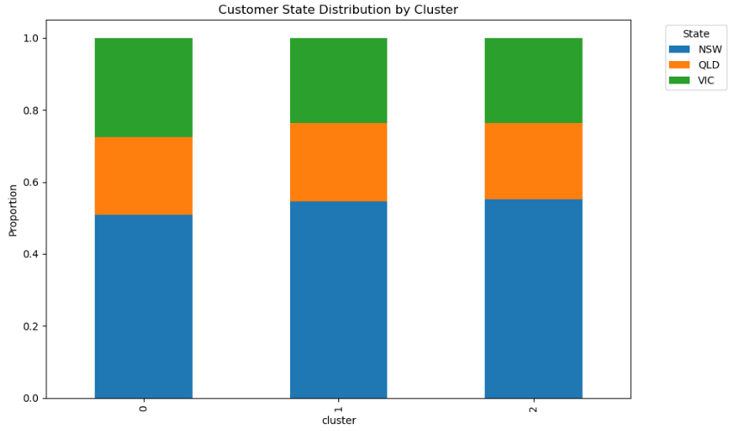
Figure 22 Customer State Distribution Bar Plot
Key Insights
- Prioritize retention of high-value loyalists: Cluster 1 customers deliver the most revenue through high spending and frequent purchases. Investing in personalized offers, early access to new products, and loyalty rewards will help sustain and grow their engagement.
- Reactivate low-engagement customers: Cluster 0’s long purchase gaps signal a risk of churn. Targeted win-back campaigns—such as seasonal promotions or personalized reminders—could bring these customers back into active purchasing cycles.
- Reinforce relationships with at-risk but long-tenured customers: Cluster 2’s long tenure but moderate activity suggests untapped potential. Tailored retention offers or exclusive loyalty tier benefits may increase their transaction frequency.
- Leverage industry-specific campaigns: Consistent presence of Manufacturing and Financial Services customers, and higher Retail representation in Cluster 2, point to opportunities for sector-tailored messaging and bundled product offers.
- Maintain geographic dominance while expanding reach: With New South Wales leading across all segments, marketing should reinforce presence in this state while exploring growth opportunities in Victoria and Queensland through localized promotions.

Conclusion
The customer segmentation project for the Australian bike store successfully identified actionable customer groups through the integration of SQL, Python, and Tableau. By segmenting customers based on transactional behavior and demographic attributes, the analysis uncovered high-value, frequent buyers, dormant customers, and growth-potential segments. The insights derived provide a foundation for implementing targeted marketing campaigns, enhancing customer engagement, and optimizing resource allocation.
The methodology ensured a comprehensive analytical process, from SQL-based data extraction and Python-driven modeling to interactive visualization in Tableau. The project not only highlighted the value of K-Means clustering in retail segmentation but also emphasized the importance of rigorous data preprocessing and visual storytelling to translate analytical findings into strategic actions.
Future iterations of this project could incorporate additional behavioral data, such as website interaction metrics, to enrich customer profiles. Moreover, exploring advanced clustering techniques like DBSCAN or hierarchical clustering could offer alternative perspectives on customer groupings. Continuous monitoring and evaluation of segmentation-driven marketing initiatives will further refine strategies and enhance business outcomes.
References
Aslantaş, G., Gençgül, M., Rumelli, M., Özsaraç, M., & Bakırlı, G. (2023). Customer segmentation using K-means clustering algorithm and RFM model. Dokuz Eylül Üniversitesi Mühendislik Fakültesi Fen ve Mühendislik Dergisi, 25(74), 491–503. https://doi.org/10.21205/deufmd.2023257418
John, J. M., Shobayo, O., & Ogunleye, B. (2024). An exploration of clustering algorithms for customer segmentation in the UK retail market. arXiv preprint arXiv:2402.04103. https://arxiv.org/abs/2402.04103
Ravi, V., & Reddy, G. (2022). K-means clustering approach for intelligent customer segmentation using customer purchase behavior data. Applied Soft Computing, 107, 107924. https://doi.org/10.1016/j.asoc.2021.107924
Sarkar, M., Roy Puja, A., & Chowdhury, F. R. (2024). Optimizing marketing strategies with RFM method and K-Means clustering-based AI customer segmentation analysis. Journal of Business and Management Studies, 6(2), 54–65. https://doi.org/10.32996/jbms.2024.6.2.5
Zhao, J. (2024). Customer segmentation application based on K-Means. ResearchGate. https://www.researchgate.net/publication/379014975_Customer_segmentation_application_based_on_K-Means
Appendices
Appendix A: SQL Query Snippets

Data Cleaning and Merging (SQL)
In [ ]:
# Hide the main window
root = tk.Tk()
root.withdraw()

# Open file dialog to select a CSV file
file_path = filedialog.askopenfilename(filetypes=[("All files", "*.*")])

# Show the selected file name
print(f"Selected file: {file_path}")

# List all sheet names to understand the data structure
xls = pd.ExcelFile(file_path)
raw_sheet_names = xls.sheet_names

raw_sheet_names
In [ ]:
# Load a sample of each sheet to inspect their columns and data types
transactions_raw = pd.read_excel(file_path, sheet_name='Transactions')
new_customer_raw = pd.read_excel(file_path, sheet_name='NewCustomerList')
demographics_raw = pd.read_excel(file_path, sheet_name='CustomerDemographic')
address_raw = pd.read_excel(file_path, sheet_name='CustomerAddress')

# Display columns of each sheet
{
"Transactions": transactions_raw.columns.tolist(),
"NewCustomerList": new_customer_raw.columns.tolist(),
"CustomerDemographic": demographics_raw.columns.tolist(),
"CustomerAddress": address_raw.columns.tolist()
}
In [ ]:
# Clean the CustomerDemographic: drop "default" and convert DOB to string
demographics_cleaned = demographics_raw.drop(columns=['default'], errors='ignore')
demographics_cleaned['DOB'] = demographics_cleaned['DOB'].astype(str)

# Clean NewCustomerList: drop unwanted columns
columns_to_drop = [col for col in new_customer_raw.columns if 'Unnamed' in col or col in ['Rank', 'Value']]
new_customer_cleaned = new_customer_raw.drop(columns=columns_to_drop, errors='ignore')
In [ ]:
# Recreate the in-memory SQLite database
import sqlite3
conn = sqlite3.connect(':memory:')

# Load dataframes into SQLite with the correct data types
transactions_raw.to_sql('Transactions', conn, index=False, if_exists='replace')
new_customer_cleaned.to_sql('NewCustomerList', conn, index=False, if_exists='replace')
demographics_cleaned.to_sql('CustomerDemographic', conn, index=False, if_exists='replace')
address_raw.to_sql('CustomerAddress', conn, index=False, if_exists='replace')
In [ ]:
# Step 1: Clean CustomerDemographic and calculate age
conn.execute("""
CREATE TABLE CleanedCustomerDemographic AS
SELECT DISTINCT
customer_id,
first_name,
last_name,
gender,
past_3_years_bike_related_purchases,
DOB,
job_title,
job_industry_category,
wealth_segment,
deceased_indicator,
owns_car,
tenure,
(CAST(strftime('%Y', 'now') AS INTEGER) - CAST(strftime('%Y', DOB) AS INTEGER)) AS age
FROM CustomerDemographic
WHERE deceased_indicator != 'Y'
AND customer_id IS NOT NULL
AND gender IS NOT NULL
""")
In [ ]:
# Step 2: Clean CustomerAddress
conn.execute("""
CREATE TABLE CleanedCustomerAddress AS
SELECT DISTINCT
customer_id,
address,
postcode,
UPPER(state) AS state,
UPPER(country) AS country,
property_valuation
FROM CustomerAddress
WHERE state IS NOT NULL
AND country IS NOT NULL
""")
In [ ]:
# Step 3: Clean Transactions
conn.execute("""
CREATE TABLE CleanedTransactions AS
SELECT DISTINCT
transaction_id,
product_id,
customer_id,
transaction_date,
online_order,
order_status,
brand,
product_line,
product_class,
product_size,
list_price,
standard_cost,
product_first_sold_date
FROM Transactions
WHERE order_status = 'Approved'
AND list_price IS NOT NULL
AND customer_id IS NOT NULL
""")
In [ ]:
# Step 4: Final Aggregated Customer Segmentation Dataset
query = """
SELECT
t.customer_id,
CASE
WHEN LOWER(cd.gender) IN ('m', 'male') THEN 'Male'
WHEN LOWER(cd.gender) IN ('f', 'female') THEN 'Female'
ELSE NULL
END AS gender,
cd.age,
cd.past_3_years_bike_related_purchases,
cd.job_industry_category,
cd.wealth_segment,
cd.owns_car,
CASE
WHEN LOWER(ca.state) IN ('new south wales', 'nsw') THEN 'NSW'
WHEN LOWER(ca.state) IN ('victoria', 'vic') THEN 'VIC'
WHEN LOWER(ca.state) IN ('qld', 'queensland') THEN 'QLD'
ELSE NULL
END AS state,
ca.country,
ca.property_valuation,
SUM(t.list_price) AS total_spent,
COUNT(t.transaction_id) AS transaction_count,
MAX(t.transaction_date) AS most_recent_purchase,
MIN(t.transaction_date) AS first_purchase
FROM
CleanedTransactions t
LEFT JOIN CleanedCustomerDemographic cd ON t.customer_id = cd.customer_id
LEFT JOIN CleanedCustomerAddress ca ON t.customer_id = ca.customer_id
GROUP BY
t.customer_id,
cd.gender,
cd.age,
cd.past_3_years_bike_related_purchases,
cd.job_industry_category,
cd.wealth_segment,
cd.owns_car,
ca.state,
ca.country,
ca.property_valuation
"""
In [ ]:
final_df = pd.read_sql_query(query, conn)

# Export as CSV
csv_path = "C:/Users/wikoromp/Desktop/final_customer_segmentation_dataset.csv"
final_df.to_csv(csv_path, index=False)

csv_path

Appendix B: Python Preprocessing and Modeling Code

Data Pre-processing
In [ ]:
# Hide the main window
root = tk.Tk()
root.withdraw()

# Open file dialog to select a CSV file
file_path = filedialog.askopenfilename(filetypes=[("All files", "*.*")])

# Show the selected file name
print(f"Selected file: {file_path}")
In [ ]:
# Load the CSV file into a DataFrame
df = pd.read_csv(file_path)

# Display the first few rows of the DataFrame
df.shape
In [ ]:
# Dataset Information
df.info()
In [ ]:
# Summary statistics
df.describe(include='all')

Missing Values Handling
In [ ]:
# Check missing values
missing_values = df.isnull().sum()
missing_values
In [ ]:
# Impute categorical features with 'Unknown' or mode
df['job_industry_category'].fillna('Unknown', inplace=True)
df['age'].fillna(df['age'].median(), inplace=True)
In [ ]:
df = df.dropna(subset=['state', 'country', 'property_valuation', 'gender', 'owns_car', 'wealth_segment', 'past_3_years_bike_related_purchases'])
In [ ]:
df.isnull().sum()

Feature Engineering
In [ ]:
# Drop customerID as it's not useful for modeling
df.drop('customer_id', axis=1, inplace=True)

# Focusing only riders age 80 or younger
df = df[df["age"] <= 80]
In [ ]:
# Converting to datetime format
df['first_purchase'] = pd.to_datetime(df['first_purchase'])
df['most_recent_purchase'] = pd.to_datetime(df['most_recent_purchase'])
In [ ]:
reference_date = df['most_recent_purchase'].max()

df['days_since_last_purchase'] = (reference_date - df['most_recent_purchase']).dt.days
df['customer_tenure_days'] = (df['most_recent_purchase'] - df['first_purchase']).dt.days
In [ ]:
df_for_profiling = df.copy()
In [ ]:
df.drop(['first_purchase', 'most_recent_purchase'], axis=1, inplace=True)

Selecting Features + Scalling and One-hot encoding
In [ ]:
df.info()
In [ ]:
df.describe(include='all')
In [ ]:
# Identify categorical columns
categorical_cols = ['gender', 'job_industry_category', 'wealth_segment', 'owns_car', 'state', 'country']

# One-hot encode categorical columns
df_encoded = pd.get_dummies(df, columns=categorical_cols, drop_first=True)

# Show result
print("Shape after encoding:", df_encoded.shape)
df_encoded.head()
In [ ]:
from sklearn.preprocessing import StandardScaler

selected_features = [
'age',
'past_3_years_bike_related_purchases',
'property_valuation',
'total_spent',
'transaction_count',
'days_since_last_purchase',
'customer_tenure_days'
]

Outlier Handling
In [ ]:
df.info()
In [ ]:
df_no_outliers = df_encoded.copy()

# IQR-based outlier removal
for col in selected_features:
Q1 = df_no_outliers[col].quantile(0.25)
Q3 = df_no_outliers[col].quantile(0.75)
IQR = Q3 - Q1
lower_bound = Q1 - 1.5 * IQR
upper_bound = Q3 + 1.5 * IQR
df_no_outliers = df_no_outliers[(df_no_outliers[col] >= lower_bound) & (df_no_outliers[col] <= upper_bound)]

print("Before outlier removal:", df_encoded.shape)
print("After outlier removal:", df_no_outliers.shape)
In [ ]:
df = df_no_outliers

Scaling
In [ ]:
df.info()
In [ ]:
# Scale the features
scaler = StandardScaler()
df[selected_features] = scaler.fit_transform(df[selected_features])
In [ ]:
df.head()

Determining optimal number of clusters with Elbow and Silhouette score method
In [ ]:
from sklearn.cluster import KMeans

# Elbow method for K = 2 to 10
sse = []
k_range = range(2, 11)
for k in k_range:
km = KMeans(n_clusters=k, random_state=42, n_init=10)
km.fit(df)
sse.append(km.inertia_)
In [ ]:
# Plot elbow curve
plt.figure(figsize=(8, 5))
plt.plot(k_range, sse, marker='o')
plt.title('Elbow Method For Optimal k')
plt.xlabel('Number of Clusters (k)')
plt.ylabel('Sum of Squared Distances (Inertia)')
plt.grid(True)
plt.tight_layout()
plt.show()
In [ ]:
from sklearn.metrics import silhouette_score

for k in range(2, 11):
km = KMeans(n_clusters=k, random_state=42, n_init=10)
cluster_labels = km.fit_predict(df)
score = silhouette_score(df, cluster_labels)
print(f"Silhouette Score for k={k}: {score:.4f}")

Fit the Model with k=3
In [ ]:
# Fit model and assign clusters
kmeans_final = KMeans(n_clusters=3, random_state=42, n_init=10)
df['cluster'] = kmeans_final.fit_predict(df)

Reduce Dimensions with PCA
In [ ]:
from sklearn.decomposition import PCA

# Reduce to 2D for plotting
pca = PCA(n_components=2)
components = pca.fit_transform(df.drop('cluster', axis=1))

# Add to DataFrame
df['pc1'] = components[:, 0]
df['pc2'] = components[:, 1]
In [ ]:
import matplotlib.pyplot as plt

plt.figure(figsize=(8, 6))
scatter = plt.scatter(df['pc1'], df['pc2'], c=df['cluster'], cmap='viridis', alpha=0.7)
plt.title("Customer Segments Visualized with PCA")
plt.xlabel("Principal Component 1")
plt.ylabel("Principal Component 2")
plt.colorbar(scatter, label='Cluster')
plt.grid(True)
plt.show()

Clustering Profiling
In [ ]:
df_for_profiling_no_outliers = df_for_profiling.loc[df_no_outliers.index].copy()
In [ ]:
# Attach cluster labels to the readable, raw-format dataframe
df_for_profiling_no_outliers['cluster'] = df_no_outliers['cluster'].values
In [ ]:
# Map numeric clusters to readable names (for Tableau / reports)
cluster_name_map = {
0: "Balanced Mid-Value Buyers",
1: "High-Value Frequent Loyalists",
2: "At-Risk or Infrequent Buyers"
}

# Add name column to both the modeling DF (if you use it) and the export DF
df['cluster_name'] = df['cluster'].map(cluster_name_map)
df_for_profiling_no_outliers['cluster_name'] = df_for_profiling_no_outliers['cluster'].map(cluster_name_map)
In [ ]:
cluster_summary = df_for_profiling_no_outliers.groupby('cluster').agg({
'age': 'mean',
'past_3_years_bike_related_purchases': 'mean',
'total_spent': 'mean',
'transaction_count': 'mean',
'gender': lambda x: x.mode()[0] if not x.mode().empty else None,
'job_industry_category': lambda x: x.mode()[0] if not x.mode().empty else None,
'state': lambda x: x.mode()[0] if not x.mode().empty else None,
'owns_car': lambda x: x.mode()[0] if not x.mode().empty else None
}).reset_index()
In [ ]:
cluster_means = df_for_profiling_no_outliers.groupby('cluster')[selected_features].mean()
sns.heatmap(cluster_means, annot=True, cmap='YlGnBu')
plt.title("Average Feature Values by Cluster")
In [ ]:
df_for_profiling_no_outliers.groupby('cluster')['gender'].value_counts(normalize=True).unstack().plot(kind='bar', stacked=True)

plt.title("Gender Distribution by Cluster")
plt.ylabel("Proportion")
plt.legend(title="Gender", bbox_to_anchor=(1.05, 1), loc='upper left')
plt.tight_layout()
plt.show()
In [ ]:
df_for_profiling_no_outliers.groupby('cluster')['job_industry_category'].value_counts(normalize=True).unstack().plot(
kind='bar', stacked=True, figsize=(10, 6)
)
plt.title("Job Industry Distribution by Cluster")
plt.ylabel("Proportion")
plt.legend(title="Industry", bbox_to_anchor=(1.05, 1), loc='upper left')
plt.tight_layout()
plt.show()
In [ ]:
df_for_profiling_no_outliers.groupby('cluster')['owns_car'].value_counts(normalize=True).unstack().plot(
kind='bar', stacked=True, figsize=(10, 6)
)
plt.title("Car Owner Distribution by Cluster")
plt.ylabel("Proportion")
plt.legend(title="Car Owner", bbox_to_anchor=(1.05, 1), loc='upper left')
plt.tight_layout()
plt.show()
In [ ]:
df_for_profiling_no_outliers.groupby('cluster')['state'].value_counts(normalize=True).unstack().plot(
kind='bar', stacked=True, figsize=(10, 6)
)
plt.title("Customer State Distribution by Cluster")
plt.ylabel("Proportion")
plt.legend(title="State", bbox_to_anchor=(1.05, 1), loc='upper left')
plt.tight_layout()
plt.show()
In [ ]:
df_for_profiling_no_outliers.groupby('cluster')['country'].value_counts(normalize=True).unstack().plot(
kind='bar', stacked=True, figsize=(10, 6)
)
plt.title("Customer Country Distribution by Cluster")
plt.ylabel("Proportion")
plt.legend(title="Country", bbox_to_anchor=(1.05, 1), loc='upper left')
plt.tight_layout()
plt.show()
In [ ]:
df_for_profiling_no_outliers.groupby('cluster')['wealth_segment'].value_counts(normalize=True).unstack().plot(
kind='bar', stacked=True, figsize=(10, 6)
)
plt.title("Customer Wealth Segment Distribution by Cluster")
plt.ylabel("Proportion")
plt.legend(title="Wealth Segment", bbox_to_anchor=(1.05, 1), loc='upper left')
plt.tight_layout()
plt.show()

Numerical Profiling
In [ ]:
# List of numerical columns to profile
numerical_cols = [
'age',
'past_3_years_bike_related_purchases',
'property_valuation',
'total_spent',
'transaction_count',
'days_since_last_purchase',
'customer_tenure_days'
]
In [ ]:
# Histograms with KDE
for col in numerical_cols:
plt.figure(figsize=(6, 3))
sns.histplot(df_for_profiling_no_outliers[col], kde=True)
plt.title(f'Distribution of {col}')
plt.xlabel(col)
plt.ylabel("Count")
plt.tight_layout()
plt.show()
In [ ]:
# Boxplots to check outliers
for col in numerical_cols:
plt.figure(figsize=(6, 3))
sns.boxplot(x=df_for_profiling_no_outliers[col])
plt.title(f'Boxplot of {col}')
plt.tight_layout()
plt.show()
In [ ]:
df_for_profiling_no_outliers.info()
In [ ]:
num_cols = [
"age",
"past_3_years_bike_related_purchases",
"property_valuation",
"total_spent",
"transaction_count",
"days_since_last_purchase",
"customer_tenure_days"
]
num_cols = [c for c in num_cols if c in df.columns]

# Groupby cluster and compute stats
num_profile = (
df_for_profiling_no_outliers.groupby("cluster")[num_cols]
.agg(["mean", "median", "min", "max", "std"])
)

# Save to Excel
num_profile.to_excel("cluster_numerical_profile.xlsx")
In [ ]:
# Flatten multi-level column names into single strings like "age_mean"
num_profile.columns = ['_'.join(col).strip() for col in num_profile.columns.values]

# Optional: reorder columns so stats are grouped by metric
ordered_cols = []
for col in ["age", "past_3_years_bike_related_purchases", "property_valuation",
"total_spent", "transaction_count", "days_since_last_purchase", "customer_tenure_days"]:
for stat in ["mean", "median", "min", "max", "std"]:
ordered_cols.append(f"{col}_{stat}")

# Keep only columns that exist
ordered_cols = [c for c in ordered_cols if c in num_profile.columns]
num_profile = num_profile[ordered_cols]

# Round numbers and reset index
num_profile = num_profile.round(2).reset_index()

# Display
print(num_profile)
In [ ]:
from itables import init_notebook_mode, show, options
init_notebook_mode(all_interactive=True)
options.scrollX = True
options.pageLength = 25

show(num_profile, maxBytes=0)

Categorical Profiling
In [ ]:
# List of categorical columns to profile
cat_cols = [
"gender",
"job_industry_category",
"wealth_segment",
"owns_car",
"state"
]

with pd.ExcelWriter("cluster_categorical_breakdowns.xlsx") as writer:
for col in cat_cols:
ct = (pd.crosstab(
df_for_profiling_no_outliers["cluster"],
df_for_profiling_no_outliers[col],
normalize="index"
) * 100
).round(1)
ct.to_excel(writer, sheet_name=col)
In [ ]:
from itables import show

for col in cat_cols:
tab = pd.crosstab(df_for_profiling_no_outliers["cluster"],
df_for_profiling_no_outliers[col],
normalize="index") * 100
tab = tab.round(2).reset_index()
print(f"\n{col} distribution by cluster:")
tab.columns.name = None
show(tab) # interactive for each category

Exporting Dataset for Tableau
In [ ]:
# Exporting Dataset for Tableau
df_for_profiling_no_outliers.to_excel(
r"C:\Users\willi\OneDrive\Desktop\Capstone Project\final_customer_segments.xlsx",
index=False
)

Appendix C: Tableau Dashboard Screenshots
